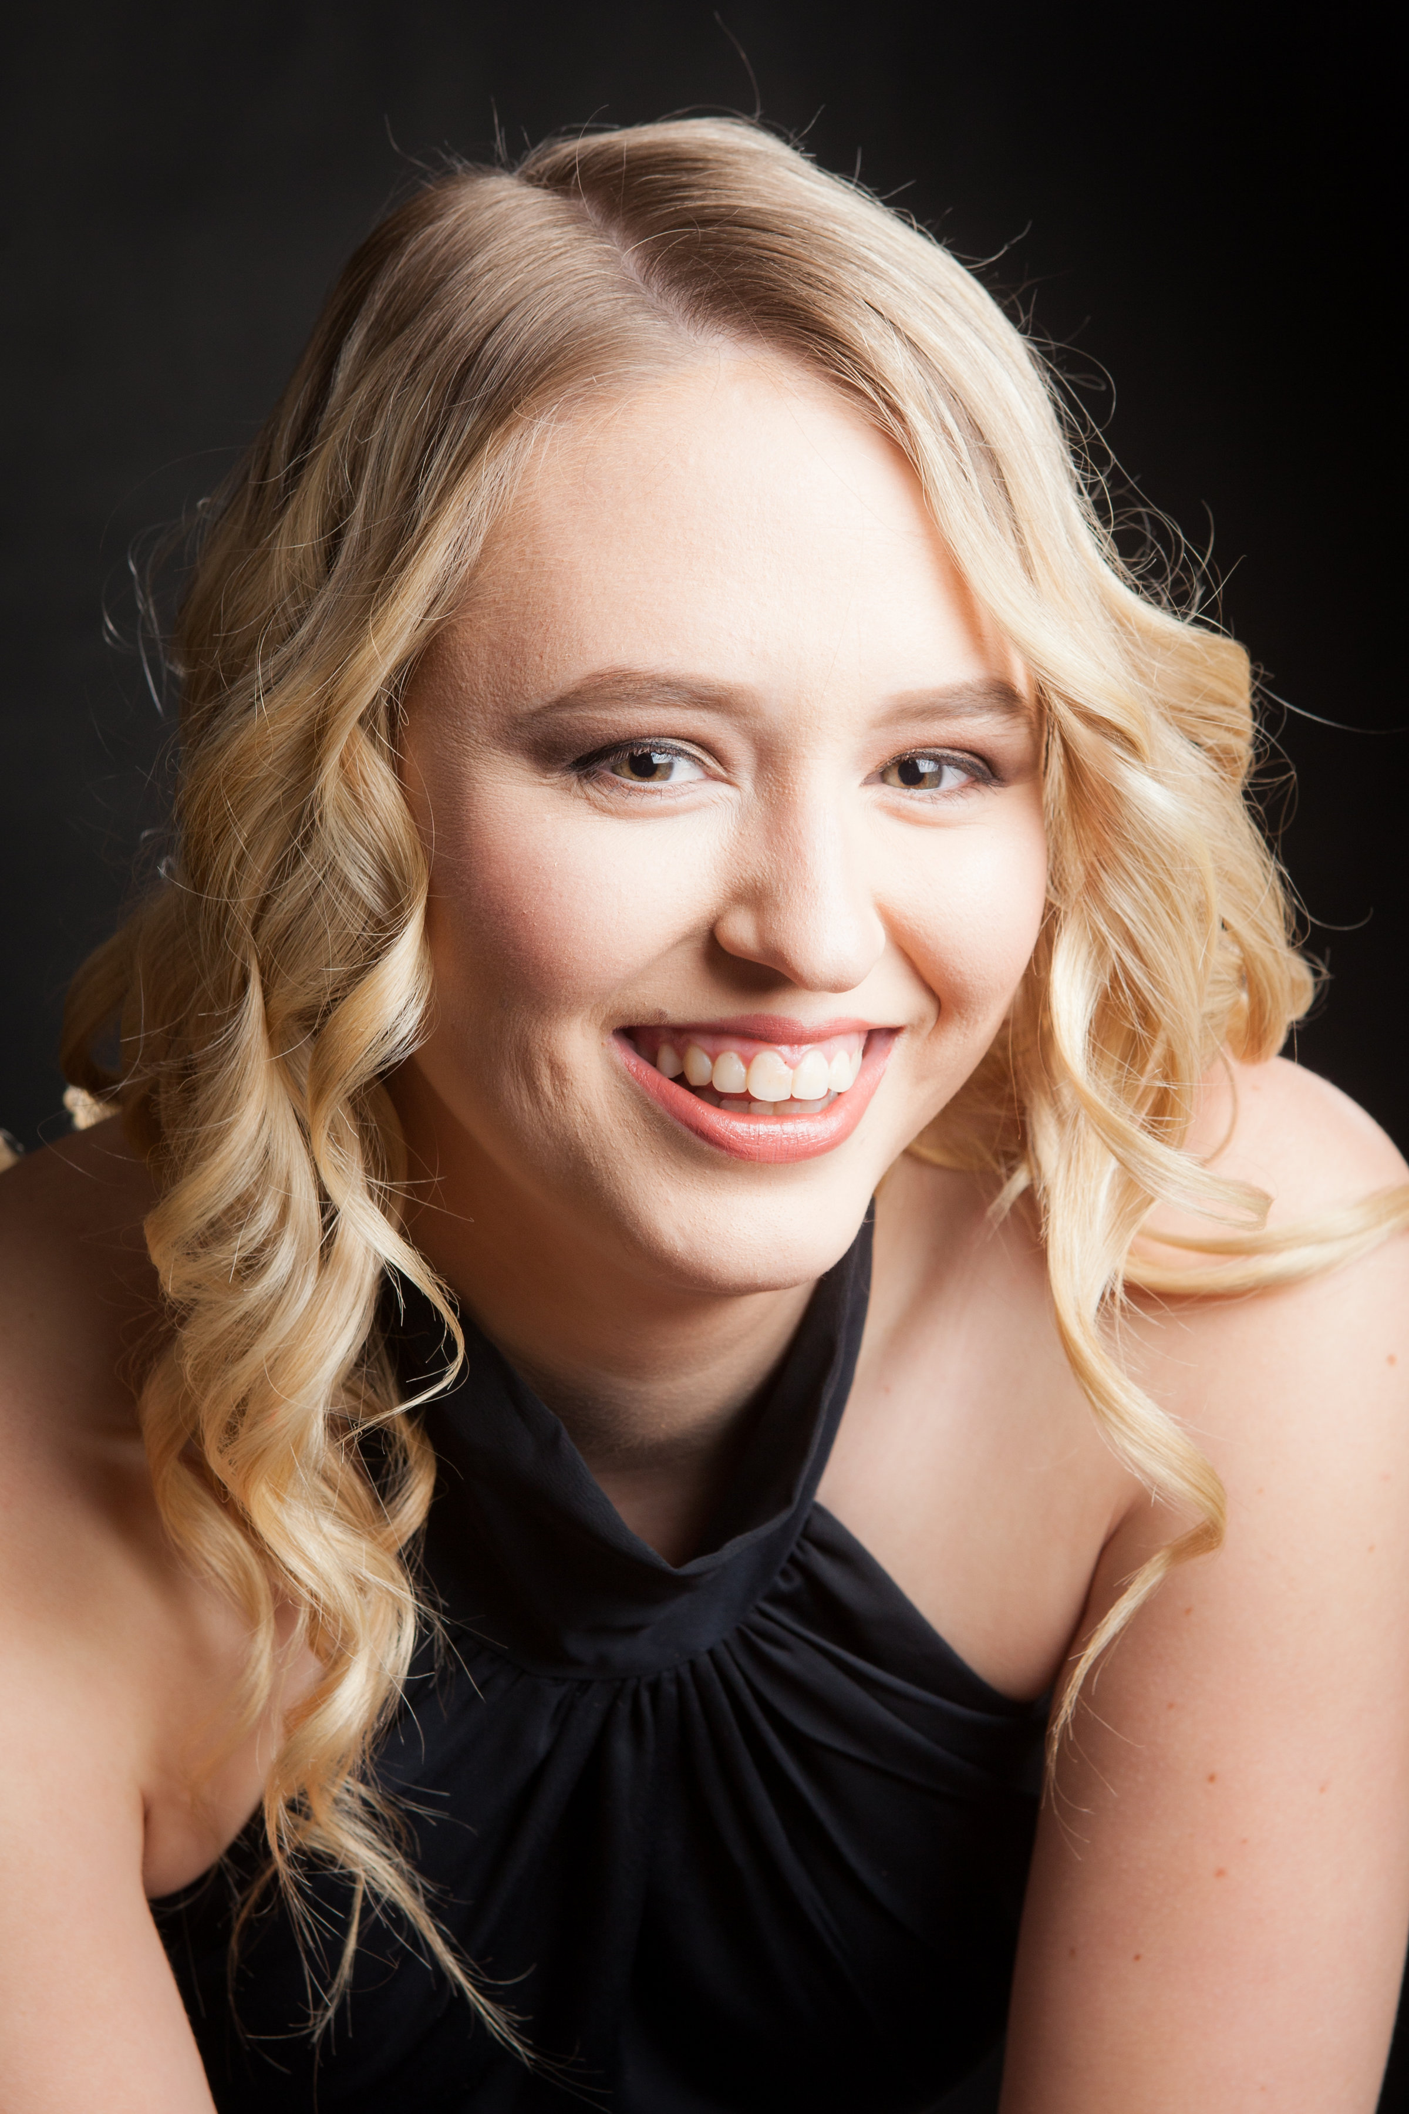
Charmaine has been involved with the performing arts since the age of 2 when she started her first dance class. As she aged, she became involved in acting leading to her being in several commercials into her early teenage years, as well as singing and instrumental studies. During her high schooling she was part of a bid winning team to the dance worlds competition that is linked into the cheerleading worlds held America two years in a row. She also performed in two performance tours to Europe as a member of the dance, cheer, choral and instrumental groups. Whilst in her senior year of schooling she completed her Cert III in Performing Arts, Cert III in Business and the first of her ADA teachers exams. Since leaving school she participated in one last tour to America performing at Madame Tussauds, Disney World and Universal Studios. Charmaine wishes to continue her dance studies whilst completing her degree in Mechanical Engineering.
Her current qualifications are:
- ADA registered teacher in Jazz, Tap & Ballet
- Acrobatics Arts Registered Teacher
- Cheerleading coach- IASF Level 1 & 2

